Infosys Springboard Virtual Internship 6.0 Completion Report

# Team Details <Do not mention any personally identifiable information like email ID, institute details, mobile phone number etc.>

Batch Number :5

Start date :13-oct-2025

Names: SEELAM KARUNYA

Internship Duration: 8 Weeks

# 1. Project Title

InsurAI Corporate Policy Automation and Intelligence System

# 2. Project Objective

# The main goal of the project is to provide an insurance management platform for automating and simplifying the most important operations: user authentication, policy selection, plan management, appointment scheduling, voice customer assistance, and admin-level user monitoring..

# 3. Project description in detail

InsurAI is a full-stack web application developed using Spring Boot (Java) for the backend, React.js for the frontend, and MySQL for database management.

**Approach**

The project was divided into multiple modules, each representing a key business operation within an insurance organization:

**Step-by-step Approach**

**Requirement Analysis:**

1. Identified users: *Customer* and *Admin*
2. Collected functional requirements:login, registration, managing plans, appointments, queries, notifications

**System Design:**

1. Designed ER diagrams and data flow

2.Created UI wireframes for login, registration, dashboard

3.Finalized database tables: Users, Plans, Appointments, Agents, Notifications

**2. Backend Development:**

1.Built RESTful APIs using **Spring Boot** (Java) and SQL

**3. Frontend Development:**

1.Built UI screens for login, registration, home page, plans, admin dashboard

2.Used axios to connect React with Spring Boot APIs

**4. Testing and Integration:**

1.Integrated all frontend components with backend APIs

2.Tested appointment creation, admin plan management, user queries

1. Ensured smooth navigation between modules

**5. Deployment:**

1. The project can be deployed on local servers or cloud for scalability.

# 4. Timeline Overview

|  |  |  |
| --- | --- | --- |
| Week | Activities Planned | Activities Completed |
| Week 1 | Login & Registration Pages | Completed |
| Week 2 | Spring boot setup | Completed |
| Week 3 | Database Design (MySQL) | Completed |
| Week 4 | Frontend–Backend API | Completed |
| Week 5 | Admin Dashboard | Completed |
| Week 6 | JWT Security | Completed |
| Week 7 | Appointment Module | Completed |
| Week 8 | Final Testing | Completed |

# 5a. Key Milestones

|  |  |  |
| --- | --- | --- |
| Milestone | Description | Date Achieved |
| Project Kickoff | Started project planning and requirement collection. | Week1 |
| Prototype/First Draft | Created basic login, registration UI and initial backend setup. | Week2 |
| Mid-Term Review | Completed authentication, dashboard, and appointment features. | Week4 |
| Final Submission | Finished all modules, testing, and documentation. | Week6 |
| Presentation | Demonstrated the working InsurAI project. | Week8 |

# 5b. Project execution details

The work was done systematically: first, the insurance workflow was understood; then the necessary technologies were learnt Java Spring Boot & React and each module was implemented step by step.I worked on the frontend and backend and connected them using REST APIs.

**Frontend Execution**

* + Login & Register
  + Customer Dashboard
  + Admin Dashboard

Added CSS and UI designs

**Backend Execution**

* REST APIs for:
  + Login / Register
  + Agent document upload
  + Admin verification and rejection
* Added JWT filters
* Developed logic for:
  + Approving users & updating database state
  + Rejecting users with reason

# 6. Snapshots / Screenshots

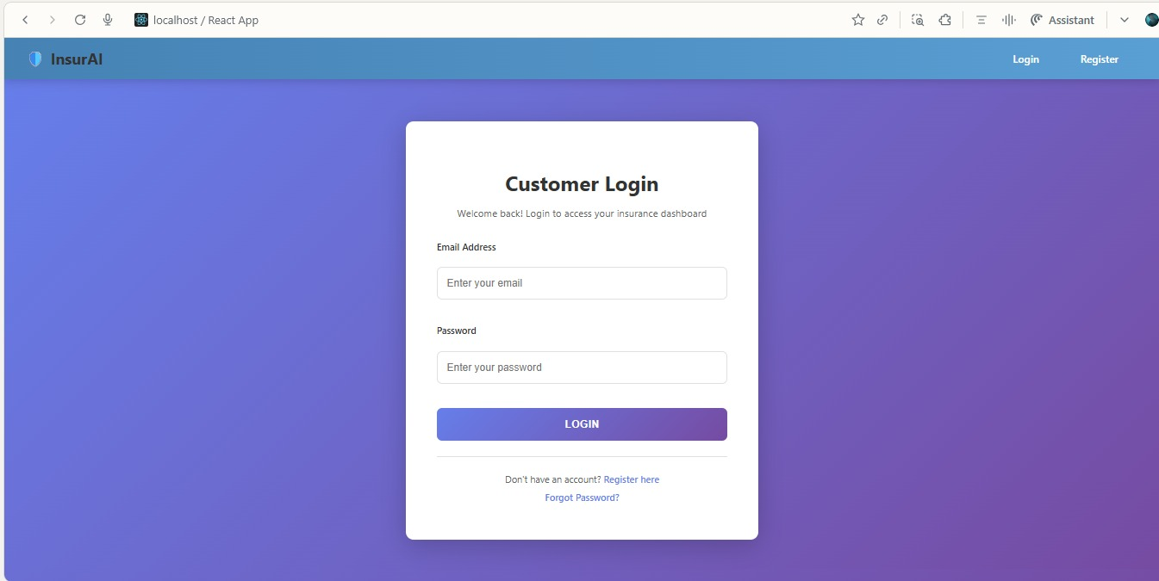

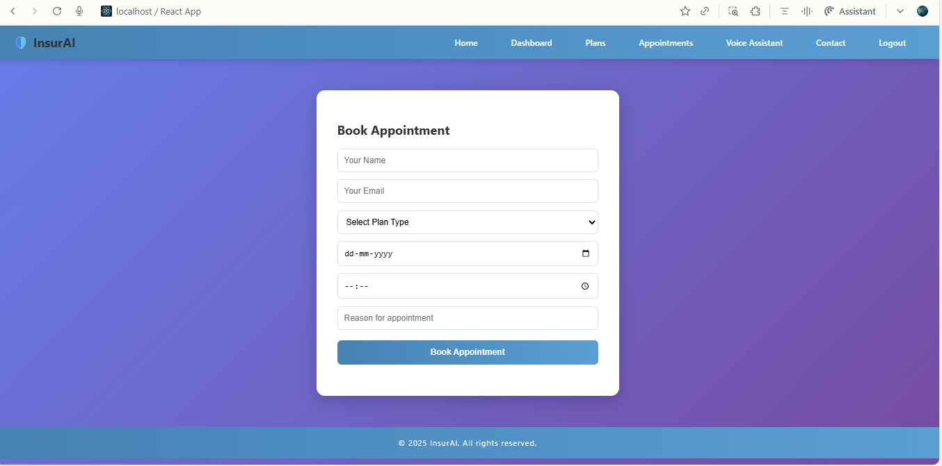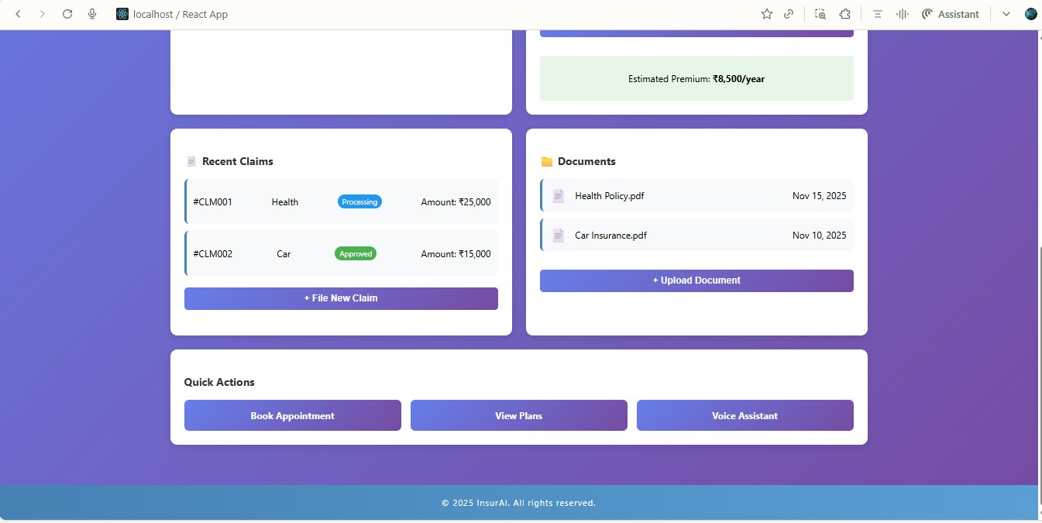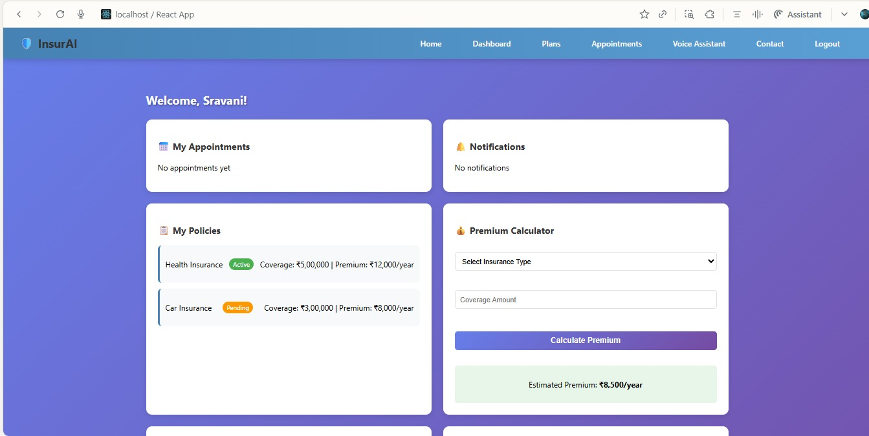

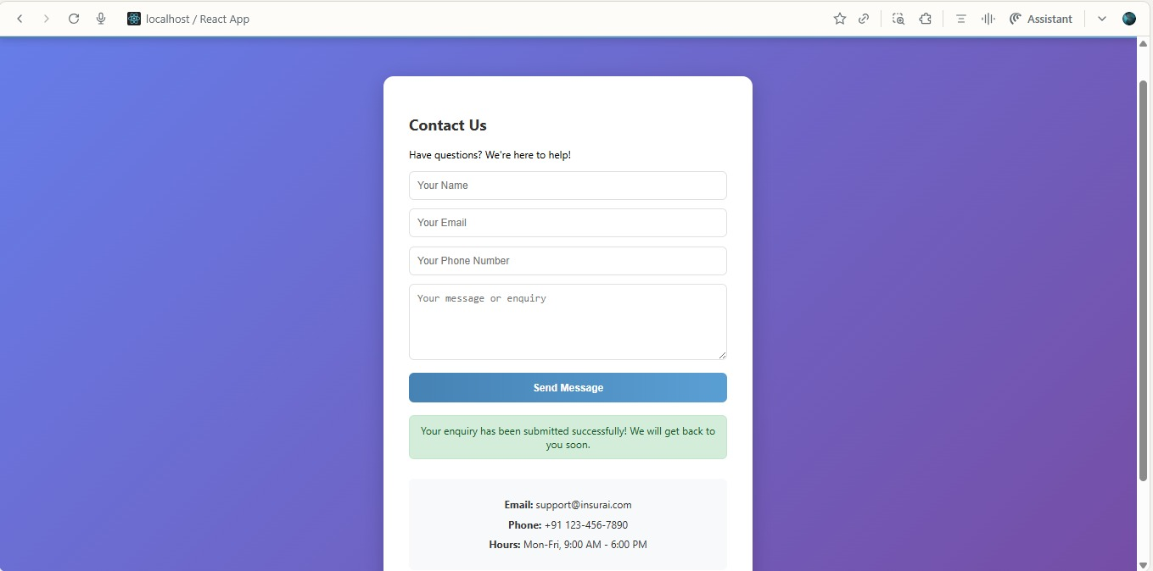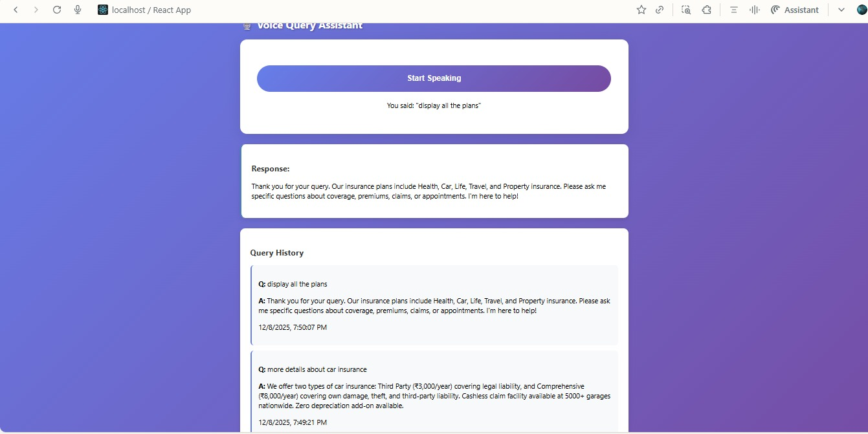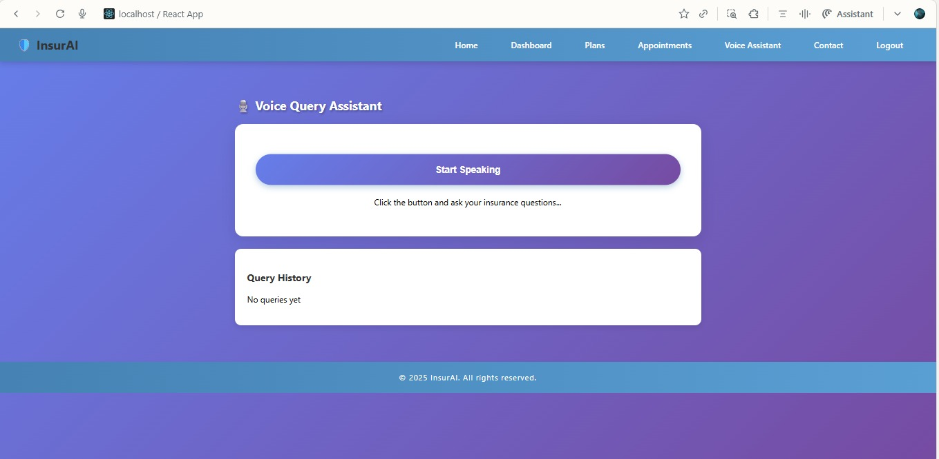

# 

# 

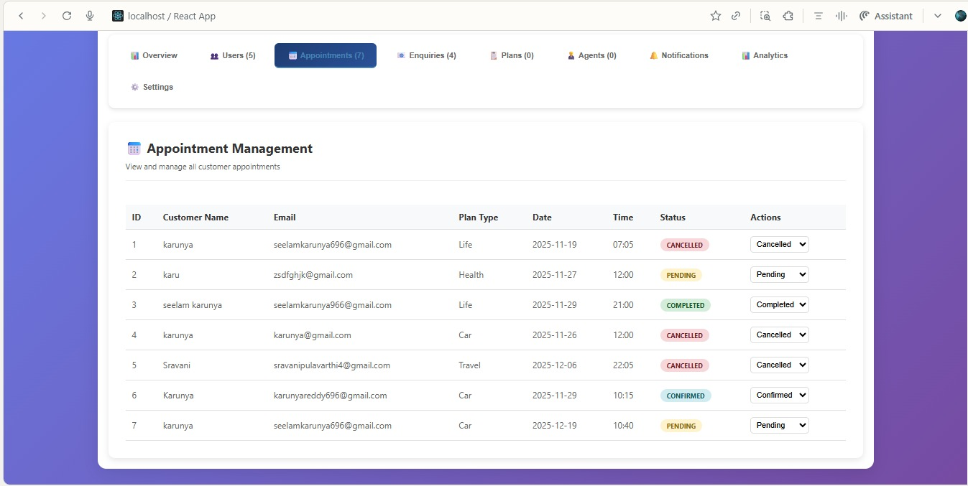

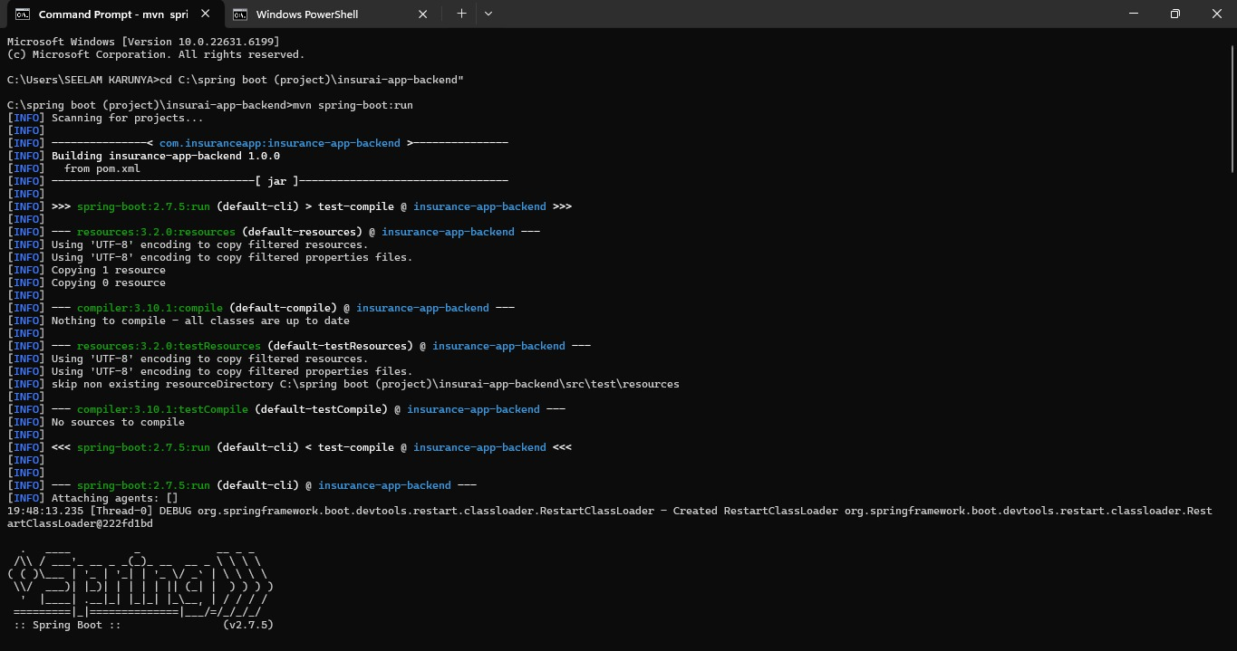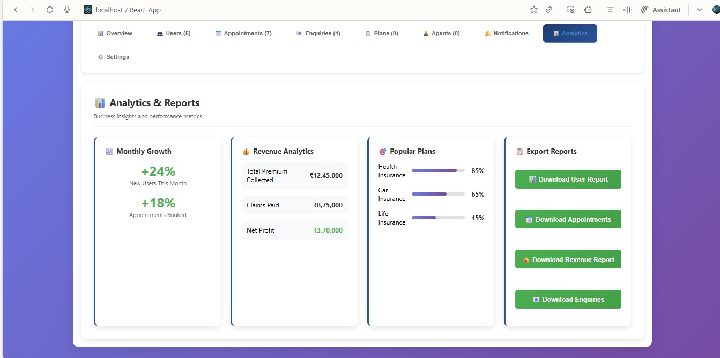

# 

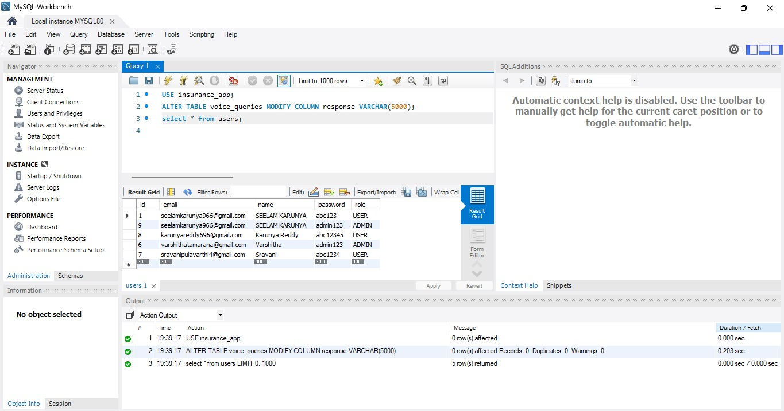

# 7. Challenges Faced

# Initially faced difficulty in setting up Maven & Spring Boot environment.

# API integration between React and Spring Boot required debugging CORS errors.

# JWT authentication and role-based redirection took time to understand.

# Managing multiple React components and routing was challenging at first.

# Appointment module needed careful logic for selecting insurance type.

# .

# 8. Learnings & Skills Acquired

**Technical Skills**

* React.js (components, state, hooks, routing)
* Java Spring Boot (REST APIs, security, dependency injection)
* MySQL (tables, queries, relationships)
* JWT Authentication
* Axios API integration
* CORS handling
* Postman Testing

**Soft Skills**

* Time management
* Problem-solving
* Requirement-based development
* Documentation and presentation

# 9. Testimonials from team

# This project gave me a better understanding of full-stack development. I did it independently by learning each concept and implementing the required modules. The handling of multiple files and connecting the frontend-backend taught me the real development workflow.

# 10. Conclusion

# The InsurAI Insurance Management System successfully demonstrates how modern insurance operations can be digitized and automated. Through this project, I gained strong hands-on experience in full-stack development using Java Spring Boot, React, and MySQL. The system is scalable and can be extended further to include AI-driven recommendation engines.

# 11. Acknowledgements

Thank the Infosys Springboard, mentor, and my team members who supported my internship journey. Their resources helped me learn new technologies effectively and complete this project successfully.